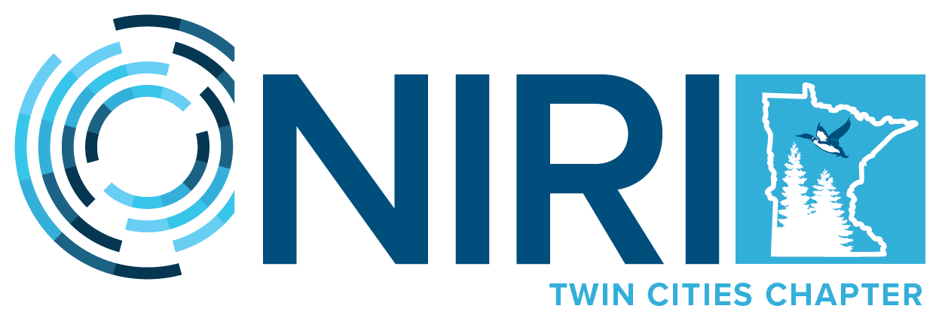
NIRI Twin Cities Chapter Elects 2022-2023 Board of Directors

MINNEAPOLIS, June 27, 2022-- The Twin Cities Chapter (www.niri-twincities.org) of the National Investor Relations Institute (NIRI) today announced the election of its officers and directors for the 2022-2023 program year, which begins July 1, 2022. A complete list of the new NIRI Twin Cities Chapter officers and board members is presented below:
- Co-President – Brandon Elliott, CFA, Founder, e2Adivsors, LLC
- Co-President – Bernadette McCormick, Director of Strategic Relations, Issuer Direct
- VP, Advocacy Ambassador – Kelly Reisdorf, Vice President Investor Relations and Communications, Vista Outdoor, Inc.
- VP, Marketing Chair – Peggy James, Sr. Investor Relations Specialist, Polaris Inc.
- VP, Membership Chair – Heather Davis, Member in Transition
- VP, Programs Co-Chair – Brandon Elliott, CFA, Founder, e2Adivsors, LLC
- VP, Programs, Co-Chair (Special Events) – Lori Lauber, Senior Director, Broadridge Financial Solutions, Inc.
- VP, Sponsorship Chair – Tim Sedabres, IRC, Head of Investor Relations, Huntington Bancshares, Inc.
- VP, Treasurer – Brooks Rennie, Vice President and Director Investor Relations, Byline Bancorp, Inc.
- At-Large Director – Andy Hedberg, Vice President, Investor Relations, Ecolab Inc.
- At-Large Director – Sam Gibbons, Vice President Investor Relations, Vireo Health International, Inc.
- At-Large Director – Darin Norman, Sr. Investor Relations Analyst, Xcel Energy Inc.
- At-Large Director – Patrick Tracey

“NIRI Twin Cities’ is proud of the exceptional slate of board members and their deep investor relations experience as they lead the chapter into another programming year,” said NIRI Twin Cities Co-President Brandon Elliott. “Our board members are privileged to continue serving so many high-profile public companies in bringing together these officers for Investor Relations professional development and networking opportunities through our high-quality programs covering current trends and issues related to the world of Investor Relations. We are appreciative of the continued dedication of chapter volunteers and sponsors who give their time and talents to make this possible.”
Please visit our website for a list of our chapter sponsors.
About the NIRI Twin Cities Chapter
Founded in 1969, NIRI is the professional association of corporate officers and investor relations consultants responsible for communication among corporate management, shareholders, securities analysts, and other financial community constituents. The NIRI Twin Cities Chapter has about 60 members. Please visit our website (www.niri-twincities.org) to learn more.
About the National Investor Relations Institute (NIRI)
Founded in 1969, NIRI is the professional association of corporate officers and investor relations consultants responsible for communication among corporate management, shareholders, securities analysts and other financial community constituents. NIRI is the largest professional investor relations association in the world with more than 3,000 members representing over 1,600 publicly held companies and $9 trillion in stock market capitalization.
Contact: Bernadette McCormick, 612-702-2833, Bernadette.McCormick@IssuerDirect.com

