Western Exploration Initiates Drill Program at Doby George
Hydrology drilling prioritized to advance the Pre-Feasibility and Baseline Studies
Reno, Nevada – July 28, 2026 – Western Exploration Inc. ("Western" or the "Company") (TSXV: WEX | OTCQX: WEXPF) is pleased to announce that preparation work has begun for a drill program at its 100%-owned Doby George gold project, located within the Aura district in northeastern Nevada (the "Doby George Project"). Site preparation is underway and the drill is scheduled to arrive during the week of July 27, 2026. The drill holes will support baseline studies and a pre-feasibility study in respect of the Doby George Project ("PFS").
The program is designed to target up to 3,000 metres across 15 drill holes. The drill holes being completed will serve as infill drilling aimed at converting mineral resources from the inferred to indicated category in the next resource estimate, and will support additional column leach test work, mineralized material and waste rock geochemical characterization and hydrogeological test work.
The hydrogeological (hydrology) test work and associated monitor wells will be used to characterize the site's water resources. This work is a key input to the Company's PFS for the Doby George Project. By prioritizing and completing this work, Western is sequencing its drilling so that the hydrogeological data is available when required, helping to advance the timeline for completing the necessary permitting requirements at the Doby George Project.
The hydrogeological data and monitor wells will complement the baseline environmental studies already underway at the Doby George Project, building the technical foundation needed to support the project's permitting and engineering workstreams. The program follows the Company's 2025 Preliminary Economic Assessment (the "PEA"), which outlined a near-surface, open-pit, heap-leach operation at the Doby George Project. See below under the heading "Scientific and Technical Information".
On July 7, 2026, Western hosted a multi-agency site visit, led by the U.S. Forest Service (the "Agency"). Agency representatives reviewed the proposed project layout on the ground and discussed the scope of work ahead. Feedback received during the visit is being incorporated into the Company's Mine Plan of Operations ("MPO") for the Doby George Project, supporting a submission that reflects Agency input from the outset. The Company expects to submit the MPO by early August 2026.
The feasibility study being completed by Raft River Rural Electric Co-operative with respect to the Company's grid power, announced in June 2026 (the "Power Study"), is progressing as anticipated, with results expected in Q4 2026. The Power Study will form part of the PFS and support the long-term development of both the Doby George Project and the Company's Gravel Creek project.
Darcy Marud, President & CEO of Western Exploration, commented: "We remain focused on advancing and completing all baseline studies and programs required to advance the Doby George Project through permitting and development. Our consultants at Stantec Consulting, Kappes Cassiday & Associates and Raft River Electric continue advancing their scopes of work. In addition, we were honored to host a multi-agency project site visit in early July and to discuss the project in an open and cooperative manner. The upcoming drill program is the next step in turning a strong economic study into a permittable, buildable project."
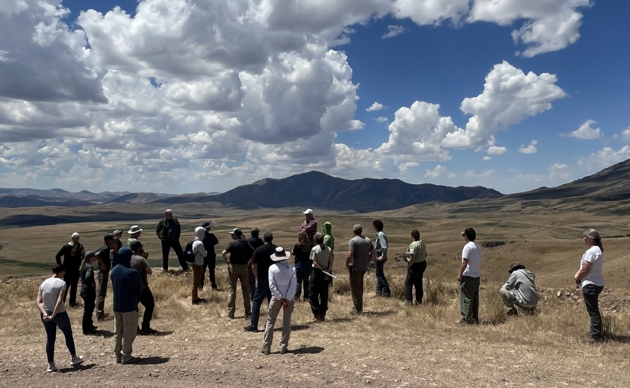
About Western Exploration Inc.
Western Exploration is a Nevada-focused gold and silver developer advancing its 100%-owned Aura project, located approximately 120 kilometres north of Elko, Nevada. The Aura project hosts two primary assets: Doby George, a near-surface oxide heap-leach project with a positive 2025 Preliminary Economic Assessment; and the Gravel Creek / Wood Gulch corridor, a high-grade gold-silver epithermal system. For more information, please refer to the PEA Technical Report. Western trades on the TSX Venture Exchange under the symbol WEX and on the OTCQX Market under the symbol WEXPF.
For further information, please contact:
Darcy Marud
Chief Executive Officer
Telephone: (775) 329-8119
Email: dmarud@westernexploration.com
Nichole Cowles
Investor Relations
Telephone: (775) 240-4172
Email: nicholecowles@westernexploration.com

Scientific and Technical Information
The scientific and technical information in this news release has been reviewed and approved by Mark Hawksworth, General Manager of the Western's Aura Project, a "qualified person" within the meaning of National Instrument 43-101 – Standards of Disclosure for Mineral Projects ("NI 43-101").
The PEA is preliminary in nature and includes inferred mineral resources that are considered too speculative geologically to have the economic considerations applied to them that would enable them to be categorized as mineral reserves, and there is no certainty that the PEA will be realized. Mineral resources that are not mineral reserves do not have demonstrated economic viability.
The PEA is more particularly described in the technical report entitled "Preliminary Economic Assessment of the Doby George Deposits and Updated Resource Estimate for the Gravel Creek Gold-Silver Deposits, Aura Gold-Silver Project, Elko County, Nevada" dated October 1, 2025 (with an effective date of June 17, 2025), which was prepared for Western and is available on SEDAR+ (www.sedarplus.ca) under Western's issuer profile (the "PEA Technical Report").
The PEA was prepared by independent representatives of KCA and RESPEC Company LLC ("RESPEC"), each of whom is a "qualified person" within the meaning of NI 43-101 and independent of Western for purposes of Section 1.5 of NI 43-101. At the effective date of the PEA, each qualified person certified that, to the best of their knowledge, information, and belief, the parts of the PEA for which they were responsible contain all scientific and technical information required to be disclosed to make the PEA not misleading. The affiliation and areas of responsibility for each qualified person involved in preparing the PEA are provided below:
- Travis Manning, P.E. of KCA – processing design and costs, metallurgy, recovery and cash flow;
- Mr. Michael S. Lindholm, C.P.G. of RESPEC – geology, database and MRE; and
- Kyle Murphy, P.E. of RESPEC – open pit design, mine planning, scheduling and costing.
Cautionary Note Regarding Forward-Looking Information
This news release may contain "forward-looking information" and "forward-looking statements" within the meaning of applicable Canadian and United States securities legislation (collectively, "forward-looking statements"). These forward-looking statements, by their nature, require the Company to make certain assumptions and involve known and unknown risks and uncertainties that could cause actual results to differ materially from those expressed or implied in such forward-looking statements. Any statement that involves predictions, expectations, interpretations, beliefs, plans, projections, objectives, assumptions, future events or performance (often, but not always, using phrases such as "expects", or "does not expect", "is expected", "interpreted", "management's view", "anticipates" or "does not anticipate", "plans", "budget", "scheduled", "forecasts", "estimates", "potential", "feasibility", "believes" or "intends" or variations of such words and phrases or stating that certain actions, events or results "may" or "could", "would", "might" or "will" be taken to occur or be achieved) are not statements of historical fact and may be forward-looking statements and are intended to identify forward-looking statements. This news release contains forward-looking statements pertaining to, among other things: the timing of the arrival of the drill and commencement of the drill program at the Doby George Project; the anticipated scope, metreage and number of drill holes in the program; the objectives of the hydrology, infill and metallurgical drilling, including the potential conversion of inferred mineral resources to indicated mineral resources; the anticipated timing of the submission of the MPO to the U.S. Forest Service; the completion and results of the grid power feasibility study with Raft River Rural Electric Co-operative and its potential to inform the PFS and support development of Doby George and Gravel Creek; the completion and timing of the PFS and baseline environmental studies; the prospects, if any, of the Doby George Project and the Wood Gulch and Gravel Creek mineral deposits; the potential to expand resources within the Gravel Creek mineralized system; future drilling at the Company's Aura project; the significance of historic exploration activities and results; and the ability to expand the existing mineral resources at the Company's Aura project.
Such factors include, among others, risks relating to delays in the arrival of drilling equipment or the commencement or completion of the drill program; delays in the preparation or submission of the MPO; the outcome of the regulatory review process and the ability of the Company to obtain required permits and approvals on anticipated timelines or at all; the results of the Power Study; the ability of exploration activities (including drill results) to accurately predict mineralization; errors in management’s geological modelling; the ability of Western Exploration to complete further exploration activities, including drilling; property and royalty interests in respect of the Aura project; the ability of the Company to obtain required approvals; the results of exploration activities; risks relating to mining activities; the global economic climate; metal prices; dilution; environmental risks; and community and non-governmental actions. Although the forward-looking information contained in this news release is based upon what management believes, or believed at the time, to be reasonable assumptions, Western Exploration cannot assure shareholders and prospective purchasers of securities of the Company that actual results will be consistent with such forward-looking information, as there may be other factors that cause results not to be as anticipated, estimated or intended, and neither Western Exploration nor any other person assumes responsibility for the accuracy and completeness of any such forward-looking information. Western Exploration does not undertake, and assumes no obligation, to update or revise any such forward-looking statements or forward-looking information contained herein to reflect new events or circumstances, except as may be required by law.
For additional information with respect to these and other factors and assumptions underlying the forward‐looking statements and forward-looking information made in this news release concerning Western Exploration, see the Company's continuous disclosure filings, including its most recent management's discussion and analysis, available electronically under Western Exploration's issuer profile on SEDAR+ (www.sedarplus.ca). The forward-looking statements set forth herein concerning Western Exploration reflect management's expectations as at the date of this news release and are subject to change after such date. Western Exploration disclaims any intention or obligation to update or revise any forward-looking statements, whether as a result of new information, future events or otherwise, other than as required by law.
Neither the TSX Venture Exchange nor its Regulation Services Provider (as that term is defined in the policies of the TSX Venture Exchange) accepts responsibility for the adequacy or accuracy of this news release. No stock exchange, securities commission or other regulatory authority has approved or disapproved the information contained herein.

