Western Exploration Advances Doby George Permitting
Phase I hydrology program complete; baseline study field work complete and baseline reports being finalized for submission to the U.S. Forest Service
Reno, Nevada – October 29, 2026 – Western Exploration Inc. ("Western" or the "Company") (TSXV: WEX | OTCQX: WEXPF) is pleased to announce the completion of Phase I of the hydrogeologic investigation at its 100%-owned Doby George gold project, part of the Company's Aura project in Elko County, northeastern Nevada (the "Doby George Project"), and the completion of all baseline study field work. These studies support the Company's Mine Plan of Operations ("MPO") for the Doby George Project, which was submitted to the United States Forest Service ("USFS") in August 2026.
Permitting process and field work at the Doby George Project include:
- Baseline studies: All field work for the baseline studies has been completed and reports are being finalized for submission to the USFS. Certain ongoing monitoring, modelling and reporting work continues, as summarized in Table 1 below.
- Hydrology: Phase I of the hydrogeologic investigation was completed, which is intended to support future development of the Doby George Project. Seven drill holes were completed and packer tested, and piezometers were installed to provide continual groundwater monitoring. The Phase I Baseline Hydrogeologic Report is in preparation, and a Phase II hydrogeologic investigation is planned for 2027.
- Air quality: Air quality and emissions studies are being finalized for submission to the USFS.
- Geochemistry and metallurgy: Material from the 2026 drill program, which includes infill drilling, is being used for geochemical characterization of mineralized material and waste rock, column leach test work and metallurgical test work. Assay results from the 2026 drill program are pending and will be released as they are received.
- Electrical feasibility: The feasibility study being completed by Raft River Rural Electric Co-operative with respect to the Company's grid power, announced in June 2026 (the "Power Study"), is nearing completion and remains on schedule for mid-December 2026.
The MPO was submitted to the USFS, the lead permitting agency, in August 2026. Hydrogeological data is a key input to the Company's pre-feasibility study for the Doby George Project ("PFS") and to the USFS review of the MPO.
Darcy Marud, CEO of Western Exploration, commented: "This field season was built around what the permitting process requires. With Phase I hydrology complete and the baseline study field work complete and reports being prepared for submittal to the Forest Service, the record supporting our Mine Plan of Operations continues to build, while drilling, geochemical and metallurgical work advance in parallel. We continue to work closely with the Forest Service through the permitting process."
Table 1: Doby George Baseline Study Progress
Resource Area | Completed | Ongoing
Biological Resources | American Goshawk Surveys  Small Mammal Surveys  Acoustic Bat Surveys  Pygmy Rabbit Surveys  Raptor Surveys (aerial and ground based)  Special Status Plants and Noxious Weed Surveys  Soil and Ecological Site Description Surveys  Flammulated Owl Surveys  Burrowing Owl Surveys  Greater Sage-Grouse Lek surveys  Migratory Bird Surveys  Amphibian and Springsnail Surveys  Three-toed Woodpecker Surveys | Biological Baseline Surveys Results Report  Soil Baseline Survey Results Report  Vegetation Baseline Survey Results Report
Cultural Resources | Class 1 Desktop Cultural Resources Review  Class 3 Cultural Resources Survey  ARPA Permit Submittal  Tribal Notification Letters Submitted  Class 3 Cultural Resources Report | N/A
Paleontological Resources | Desktop Review and Historical Records Search  Desktop Review Results Report Submitted to USFS  Paleontological Surveys  Paleontological Surveys Results Report submitted to USFS | N/A
Air Quality Resources | Initial Review of Project and Operations Data  Development of Air Quality Baseline Report | Emissions Inventory Development  Dispersion Monitoring
Hydrogeology Resources | Hydrogeology Data Review and Gap Analysis  Hydrogeology Resources Investigation and Baseline Monitoring Work Plan  Surface and Groundwater Data Review and Gap Analysis  Q2 & Q3 Spring & Stream Monitoring and Sampling  Phase I Hydrogeologic Investigation (summer 2026) | Phase I Baseline Hydrogeologic Report  Q4 spring and stream monitoring and sampling  Phase II Hydrogeologic Investigation (2027)  Phase II Baseline Hydrogeologic Report
Geochemistry Resources | Geochemistry Data Review and Gap Analysis  Geochemical Characterization Work Plan  Finalize collection and submission of samples for static and kinetic characterization | Geochemical Characterization Summary Report
Noise Resources | Baseline Noise Monitoring | Noise Modeling Predictions  Technical Noise Report
Aquatic Resources | Desktop Aquatic Resources Inventory  Aquatic Resource Surveys  Aquatic Resources Delineation Report | United States Army Corps of Engineers permitting coordination

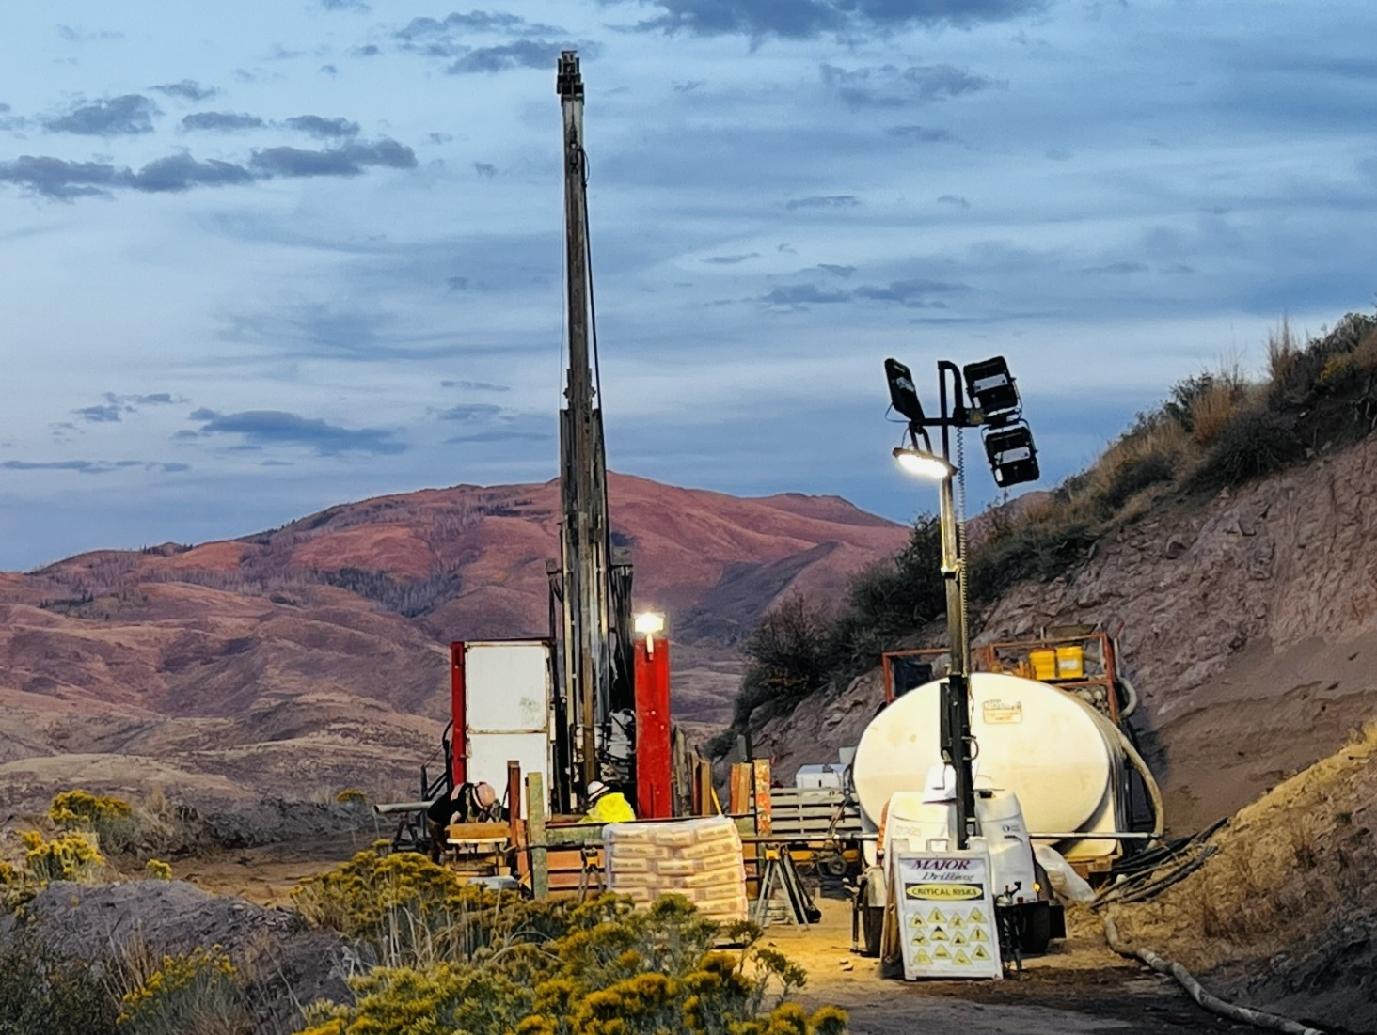
About Western Exploration Inc.
Western Exploration is a Nevada-focused gold and silver developer advancing its 100%-owned Aura project, located approximately 120 kilometres north of Elko, Nevada. The Aura project hosts two primary assets: Doby George, a near-surface oxide heap-leach project that is the subject of the PEA (as defined below); and the Gravel Creek / Wood Gulch corridor, a high-grade gold-silver epithermal system. For more information, please refer to the PEA Technical Report (as defined below). Western trades on the TSX Venture Exchange under the symbol WEX and on the OTCQX Market under the symbol WEXPF.
For further information, please contact:
Darcy Marud
Chief Executive Officer
Telephone: (775) 329-8119
Email: dmarud@westernexploration.com
Nichole Cowles
Investor Relations
Telephone: (775) 240-4172
Email: nicholecowles@westernexploration.com
Scientific and Technical Information
The scientific and technical information in this news release has been reviewed and approved by Mark Hawksworth, General Manager of Western's Aura project, a "qualified person" within the meaning of National Instrument 43-101 – Standards of Disclosure for Mineral Projects ("NI 43-101"), who is not independent of the Company.
The Company's 2025 Preliminary Economic Assessment for the Doby George Project (the "PEA") is preliminary in nature and includes inferred mineral resources that are considered too speculative geologically to have the economic considerations applied to them that would enable them to be categorized as mineral reserves, and there is no certainty that the PEA will be realized. Mineral resources that are not mineral reserves do not have demonstrated economic viability.
The PEA is more particularly described in the technical report entitled "Preliminary Economic Assessment of the Doby George Deposits and Updated Resource Estimate for the Gravel Creek Gold-Silver Deposits, Aura Gold-Silver Project, Elko County, Nevada" dated October 1, 2025 (with an effective date of June 17, 2025), which was prepared for Western and is available on SEDAR+ (www.sedarplus.ca) under Western's issuer profile (the "PEA Technical Report").
The PEA was prepared by independent representatives of Kappes, Cassiday & Associates ("KCA") and RESPEC Company LLC ("RESPEC"), each of whom is a "qualified person" within the meaning of NI 43-101 and independent of Western for purposes of Section 1.5 of NI 43-101. At the effective date of the PEA, each qualified person certified that, to the best of their knowledge, information, and belief, the parts of the PEA for which they were responsible contain all scientific and technical information required to be disclosed to make the PEA not misleading. The affiliation and areas of responsibility for each qualified person involved in preparing the PEA are provided below:
- Travis Manning, P.E. of KCA – processing design and costs, metallurgy, recovery and cash flow;
- Michael S. Lindholm, C.P.G. of RESPEC – geology, database and mineral resource estimate; and
- Kyle Murphy, P.E. of RESPEC – open pit design, mine planning, scheduling and costing.
Cautionary Note Regarding Forward-Looking Information
This news release may contain "forward-looking information" and "forward-looking statements" within the meaning of applicable Canadian and United States securities legislation (collectively, "forward-looking statements"). These forward-looking statements, by their nature, require the Company to make certain assumptions and involve known and unknown risks and uncertainties that could cause actual results to differ materially from those expressed or implied in such forward-looking statements. Any statement that involves predictions, expectations, interpretations, beliefs, plans, projections, objectives, assumptions, future events or performance (often, but not always, using phrases such as "expects", or "does not expect", "is expected", "interpreted", "management's view", "anticipates" or "does not anticipate", "plans", "budget", "scheduled", "forecasts", "estimates", "potential", "feasibility", "believes" or "intends" or variations of such words and phrases or stating that certain actions, events or results "may" or "could", "would", "might" or "will" be taken to occur or be achieved) are not statements of historical fact and may be forward-looking statements and are intended to identify forward-looking statements. This news release contains forward-looking statements pertaining to, among other things: the finalization of baseline study reports and their submission to the USFS; the preparation of the Phase I Baseline Hydrogeologic Report; the Phase II hydrogeologic investigation; the completion of air quality and emissions studies and their submission to the USFS; continual groundwater monitoring at the Doby George Project; the timing of assay results from the 2026 drill program; geochemical, column leach and metallurgical test work; the completion and timing of the Power Study; the USFS review of the MPO and the associated environmental review process; the use of hydrogeological data in the PFS and future development of the Doby George Project; the completion and timing of the PFS; the prospects, if any, of the Doby George Project and the Wood Gulch and Gravel Creek mineral deposits; future drilling at the Company's Aura project; and the ability to expand the existing mineral resources at the Company's Aura project.
Forward-looking statements are subject to a variety of risks and uncertainties which could cause actual events or results to differ from those reflected in the forward-looking statements. Such factors include, among others, risks relating to delays in the completion of baseline study reports or their submission to the USFS; delays in the receipt of assay results; delays in the completion of the Power Study and its results; requests by the USFS or cooperating agencies for additional information or studies; the outcome of the regulatory review process and the ability of the Company to obtain required permits and approvals on anticipated timelines or at all; the ability of exploration activities (including drill results) to accurately predict mineralization; errors in management’s geological modelling; the ability of Western Exploration to complete further exploration activities, including drilling; property and royalty interests in respect of the Aura project; the ability of the Company to obtain required approvals; the results of exploration activities; risks relating to mining activities; the global economic climate; metal prices; dilution; environmental risks; and community and non-governmental actions. Although the forward-looking information contained in this news release is based upon what management believes, or believed at the time, to be reasonable assumptions, Western Exploration cannot assure shareholders and prospective purchasers of securities of the Company that actual results will be consistent with such forward-looking information, as there may be other factors that cause results not to be as anticipated, estimated or intended, and neither Western Exploration nor any other person assumes responsibility for the accuracy and completeness of any such forward-looking information.
For additional information with respect to these and other factors and assumptions underlying the forward‐looking statements and forward-looking information made in this news release concerning Western Exploration, see the Company's continuous disclosure filings, including its most recent management's discussion and analysis, available electronically under Western Exploration's issuer profile on SEDAR+ (www.sedarplus.ca). The forward-looking statements set forth herein concerning Western Exploration reflect management's expectations as at the date of this news release and are subject to change after such date. Western Exploration disclaims any intention or obligation to update or revise any forward-looking statements, whether as a result of new information, future events or otherwise, other than as required by law.
Neither the TSX Venture Exchange nor its Regulation Services Provider (as that term is defined in the policies of the TSX Venture Exchange) accepts responsibility for the adequacy or accuracy of this news release. No stock exchange, securities commission or other regulatory authority has approved or disapproved the information contained herein.

